Planning Materials

## Physical Agile Board

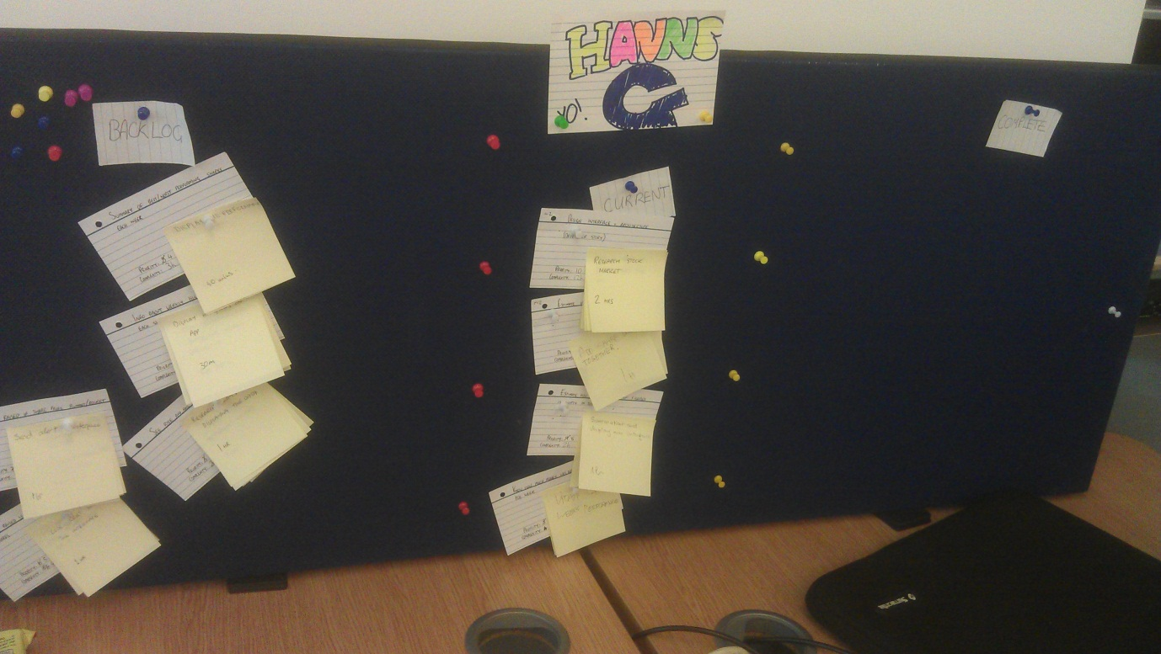

## Digital Agile BoardC:\Users\Sam\Documents\GitHub\AgileHannsGProject\665279_10151201900588259_1201576409_o.jpg

**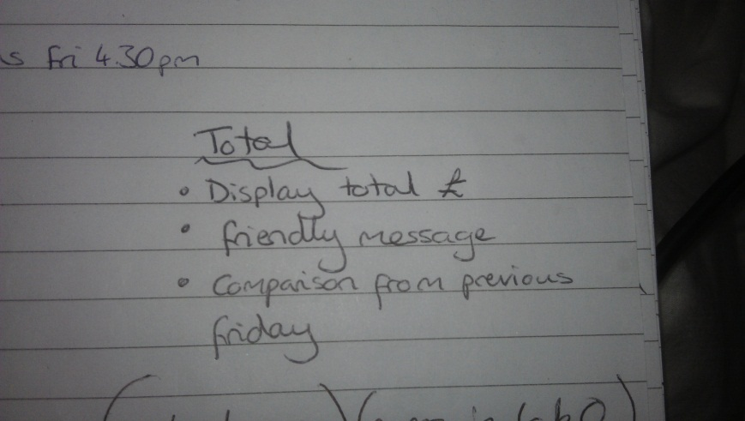**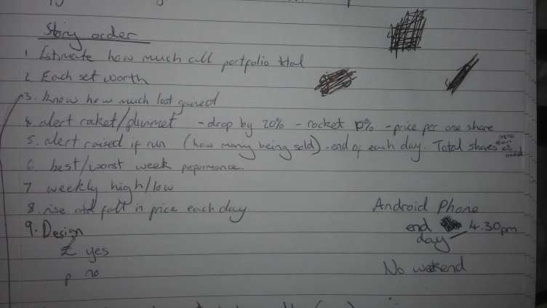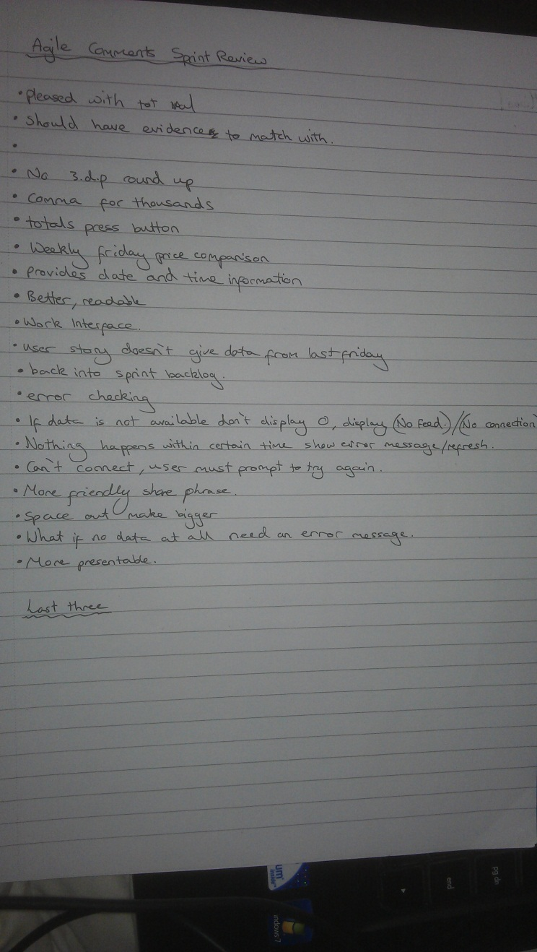Notes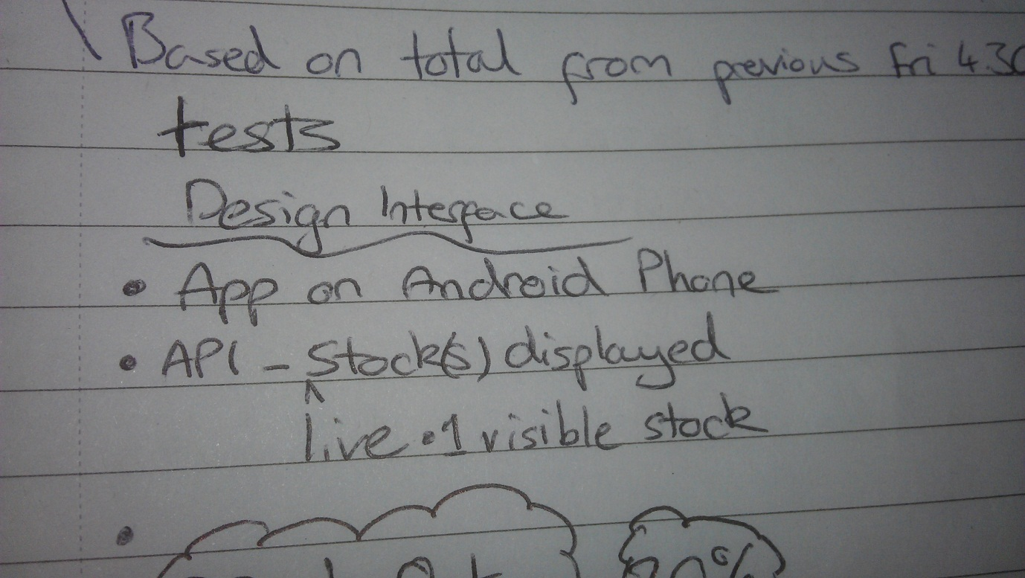

## Sprint Backlog

Included on USB stick

## App After Sprint 1

